**Content**

1. Linux 2

1. Systemd 2

1.1.1. Linux boot 2

1.1.2. What does the .d stand for in directory names? 2

1.1.3. Daemonds 3

1.1.4. Notes 3

1. Linux
   1. Systemd
      1. Linux boot
2. Turn on the computer
3. BIOS on motherboard checks the IO devices
4. Boot loader searches for boot sector on first hard drive

LILO – Linux Loader. It is a boot loader, which loads the Linux osperating system into main memory, so that it can begin its operations.

1. The linux kernel
2. RAM
3. Initialization System

* /sbin/init
* /etc/inittab
* 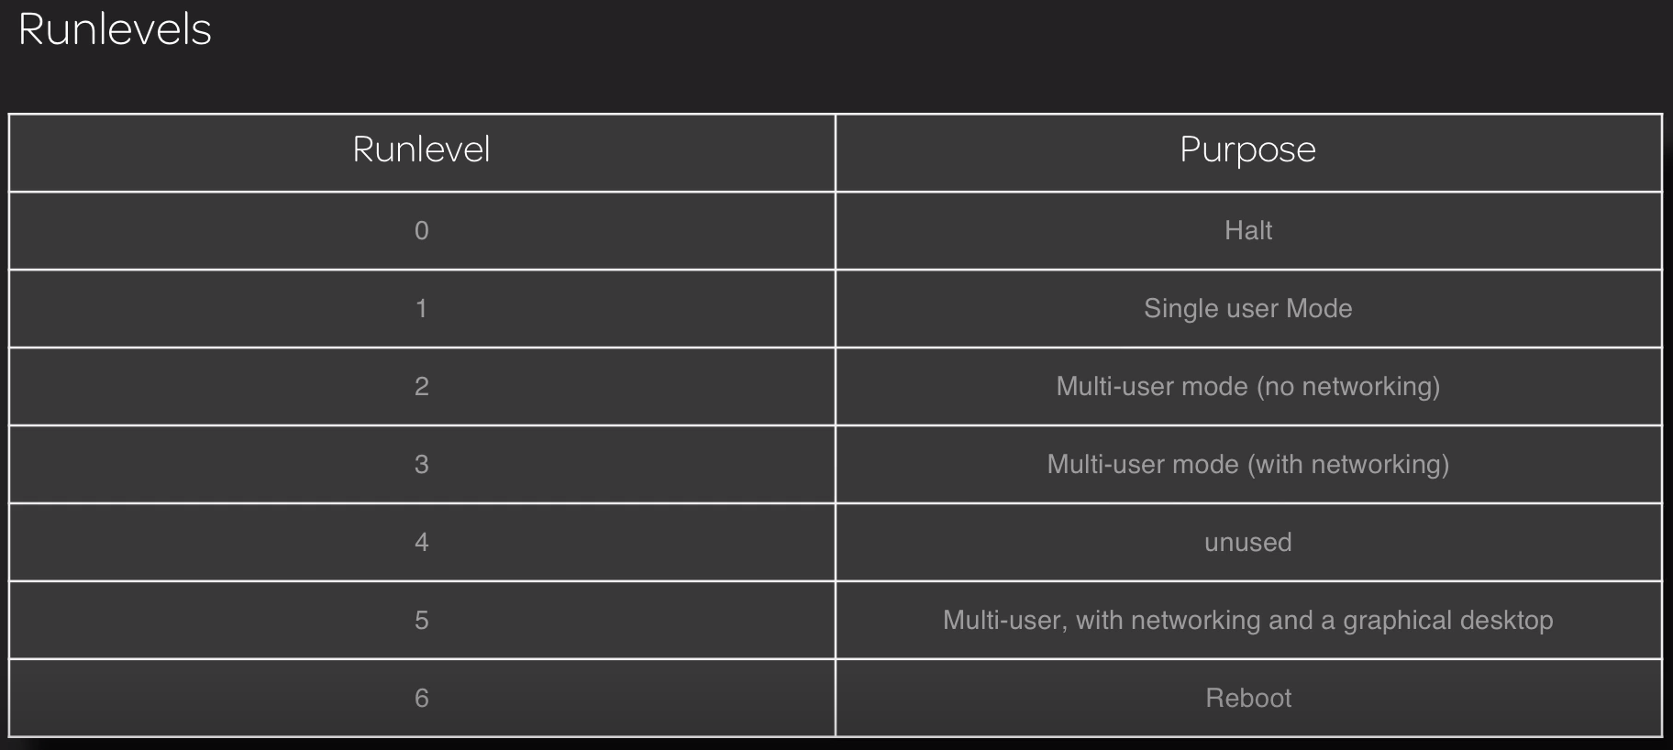
  + 1. What does the .d stand for in directory names?

The .d suffix here means directory. Of course, this would be unnecessary as Unix doesn't require a suffix to denote a file type but in that specific case, something was necessary to disambiguate the commands (/etc/init, /etc/rc0, /etc/rc1 and so on) and the directories they use (/etc/init.d, /etc/rc0.d, /etc/rc1.d, ...)

This convention was introduced at least with Unix System V but possibly earlier. The initcommand used to be located in /etc but is generally now in /sbin on modern System V OSes.

Note that this convention has been adopted by many applications moving from a single file configuration file to multiple configuration files located in a single directory, eg: /etc/sudoers.d

Here again, the goal is to avoid name clashing, not between the executable and the configuration file but between the former monolithic configuration file and the directory containing them.

* + 1. Daemonds

Equivalent to a Mocrosoft Windows Service, used for importatnt background tasks.

A daemon is a type of program that runs in the background, free of user control. They can be activated (initated as a process) by the occurence of a specific event or condition. Daemons accomodate service requests from ther programs or hardware activity or requests from other computers on the network. After the request is serviced, the Daemon disconnects and waits for further requests.

* + 1. Notes
* (rc – run commands)
* Debian (distribution – Kali, Ubuntu)
* Fedora (distribution – Red Hat, CentOS)
* Chkconfig
* Service (runs a sysvinit script to manage a service (such as start, stop, reload, etc.)
* Linux is just a **Kernel**, a **Linux distribution** makes it usable operating systems
* **Mainframes** are a type of computer that generally are known for their large size, amount of storage, processing power and high level of reliability. They are primarily used by large organizations for mission-critical applications requiring high volumes of data processing
* A Kernel is a program at the heart of the OS that takes care of fundamental stuff, like letting hardware communicate with software.
* Ubuntu – upstart (start services on init async)
* Unix – is a proprietary OS from Bell Labs (proprietary = marketed under and protected by a registered trade name). IBM(AIX), Solaris(Sun OS), HP(HP-UX), Apple(OSX) ahve their own licensed unix.
* GNU – **G**NU’s **N**ot **U**nix, Richard Stallman (recursive acronym)
* Linux OS -> Linux Kernel + GNU utilities

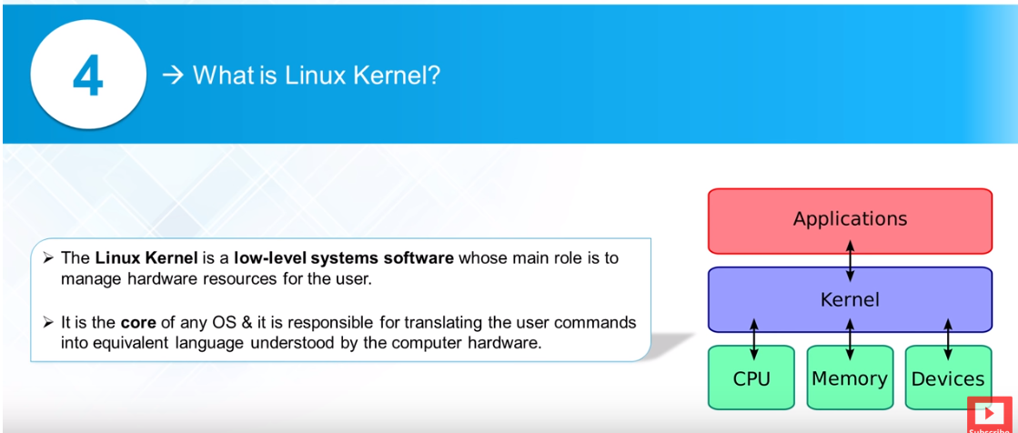

* Posix – set of formal dscriptions that provide a standard for the design of OS, especially ones which are compatible w Unix.

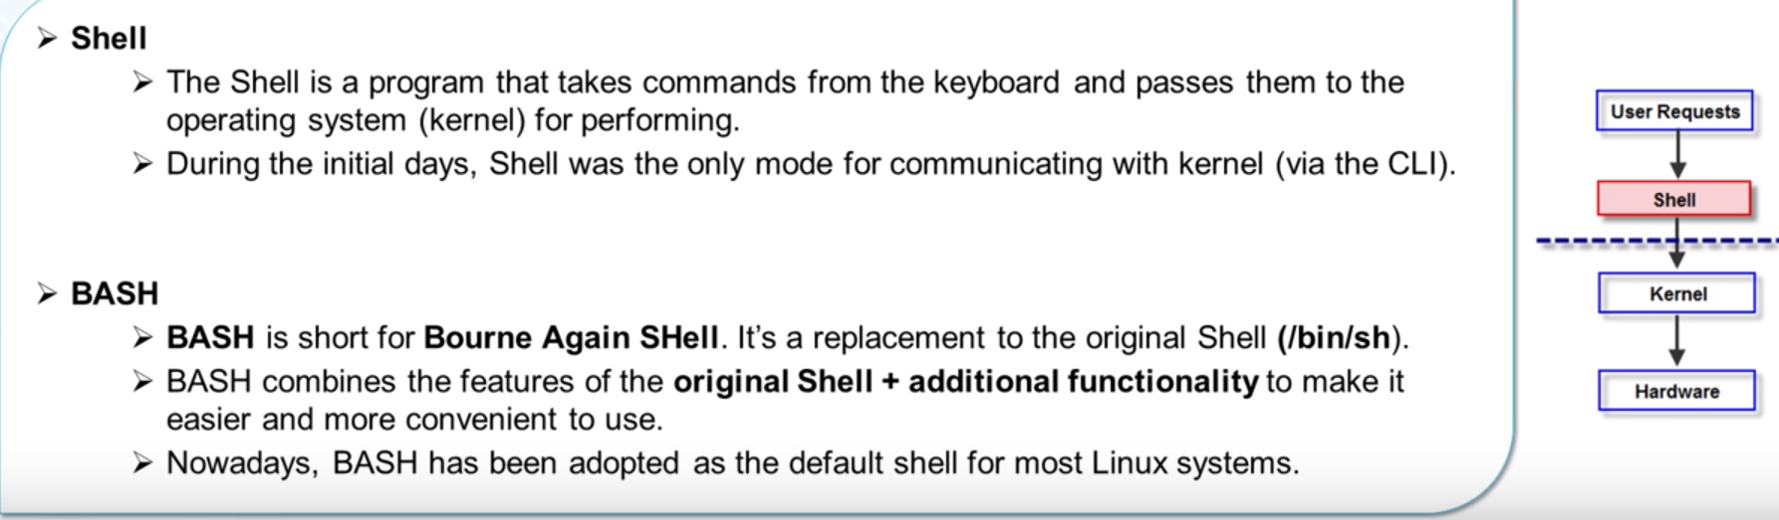

* Cat /etc/shells
* Env var: echo $SHELL – default shell